Reading4  
*Lonneke Lammers  
10371672*

Questions

1. Patterns and colors are essential to maps. Compare a search for Harvard University on two interactive maps (e.g., Google Maps, Bing Maps, Yahoo! Maps, Apple Maps, map.harvard.edu). Answer the following questions, making references to concepts explained in Ware such as pattern recognition and properties of color. Please include screenshots of the examples you are comparing.
   1. Which map promotes an easier visual search for buildings?
   2. Which map more effectively visualizes routes from a random point A to point B?
   3. Which map is an overall better visualization, and why?
2. Find a rainbow color map visualization on the web. Please include a screenshot and link of the visualization.
   1. Briefly summarize its intended objective and audience. Does it fail to successfully convey information? If so, why? Is there a good reason for this specific visualization to use a rainbow color scheme?
   2. Propose an alternative color scheme to replace the rainbow color map

Answers

1. Maps I have chosen are the the *harvard.edu-map* and the *Apple Maps*.
   1. The map of Harvard promotes an easier visual search for buildings. The buildings are colored yellow with green around it which I guess is grass. Also some not important buildings are showed in a light grey color. On the Apple Maps there is an function where you can view the map via satalite, but I must say that the buildings appear not very clear.
   2. The Apple map visualizes routes from A to B more effectively because you can see the streets very clearly. Also you can see which streets are big streets, the yellow ones, and the grey ones are smaller streets. It’s a very clean map. The map of Harvard has streets only colored grey.
   3. 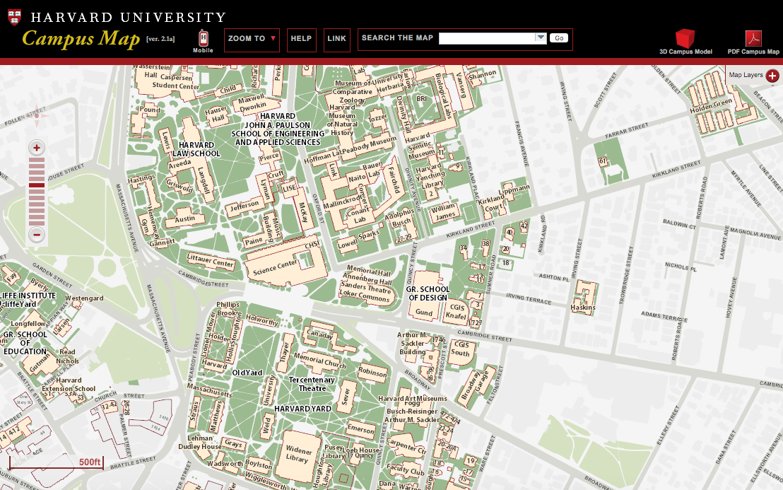I think the Apple map is an overall better visualization in comparison with the Harvard-map. Of course the map of Harvard is made for Harvard and handy to use if you know where you must be in that area. Is shows a lot of details of that particular place. But the Apple Map is better in general which might be useful for everybody. Also the colors on this map are nice to look at.

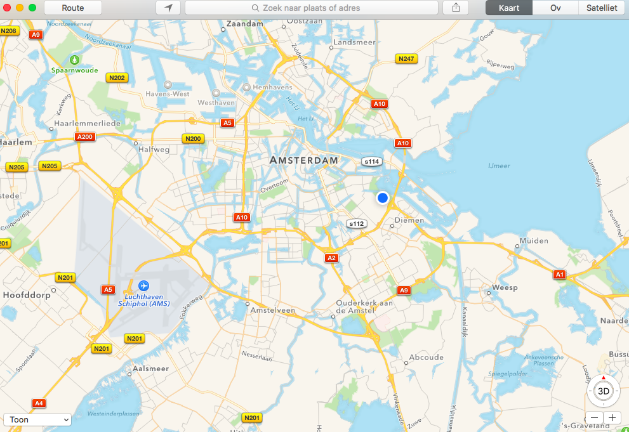

1. The rainbow colormap I have chosen is an image of the ocean presented in the colors of the rainbow colormap.
   1. Its intended objective is to show viewers the oceantemperature and its audience is everyone who is interested in the temperature of the ocean. I think to visulize the tmeperature this is quite a good way of use of the rainbow colormap, as ‘red’ means a higher temperature. Red is a warm color so that fits good together. And blue is a colder color, and also means a colder oceantemperature in this picture.
   2. I think the rainbow colormap goes quite good together with this picture of ocean’s temperature. But possibly I think good alternative colorscheme will be only the colors red and blue, and than work with hue’s. Because now the color in between (orange, yellow and green) are not really giving you a feeling of ‘cold’ or ‘warm’ what blue and red respectively do.

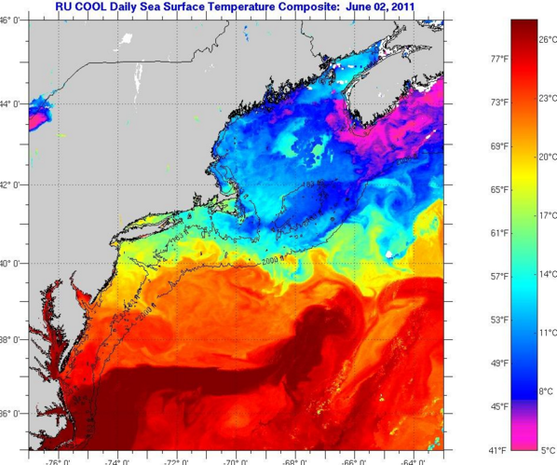http://coseenow.net/visual-ocean/tag/colormap/